2.5 Structures for Environmental Learning

Activity Title | Date | Description (1-2 Sentences) | Metrics
THS Greenhouse | 2022-2023 SY | Towson High School’s greenhouse houses the school vegetables, house plants, young trees, and flowers. The greenhouse vegetables promote instruction on sustainable crop growing. At the end of the year, harvested fruits and vegetables are shared among Environmental Club members. About 20 students are active weekly in the greenhouse | - 2 banana trees  - lemon tree  - apple tree  - Tomatoes  - Milkweed nursey  - Succulent propagation center  - Maryland native flowers
Native Memorial Garden | 2021-2022 SY  2022-2023 SY |  | The memorial garden at THS is helpful in instruction about native plant species and their benefits, the life cycles of perennials, and the benefits of green spaces.

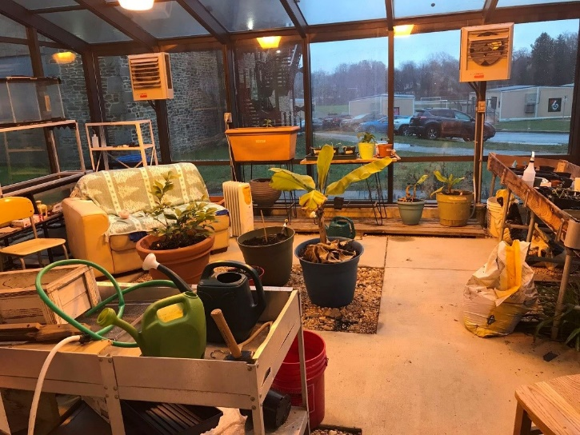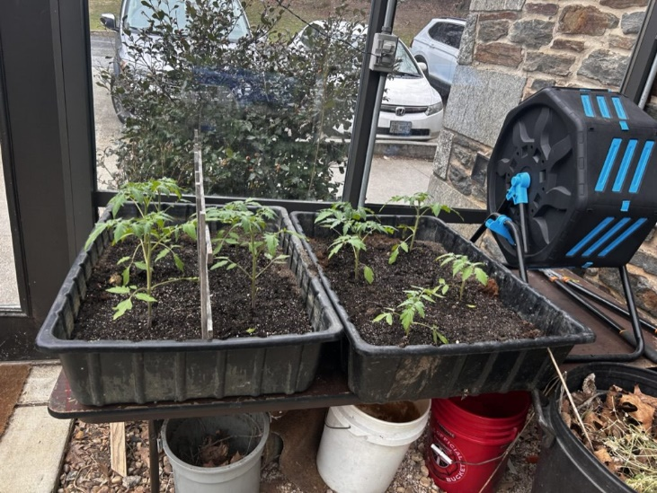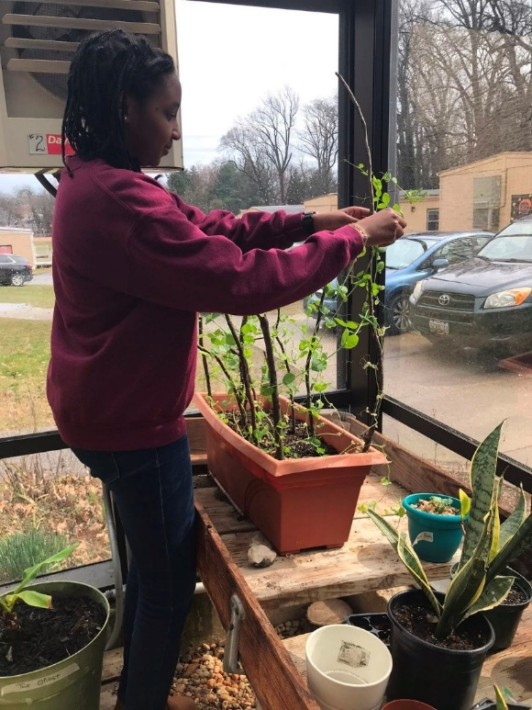
THS Greenhouse

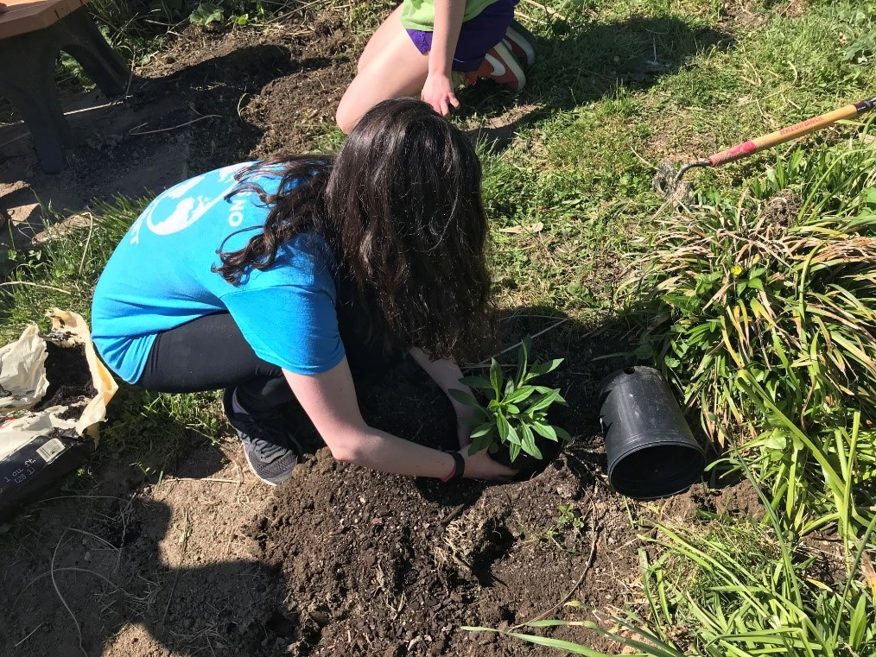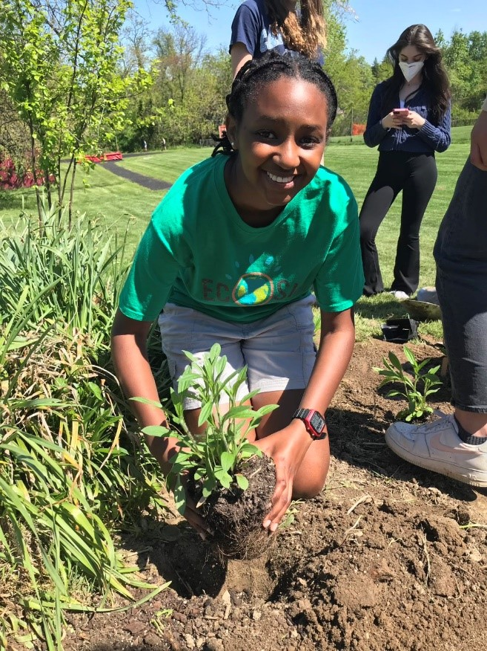
THS Native Memorial Garden

